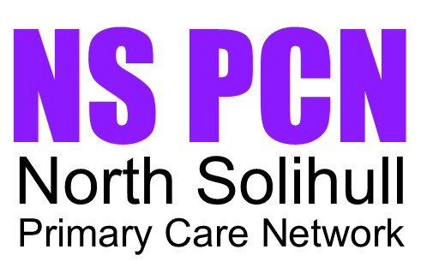

Complaints and Feedback
We are committed to providing high quality care and services to all our patients. We value your feedback and take complaints seriously as they help us improve the services we provide.
How to Raise a Concern or Complaint
If you are unhappy with any aspect of your care or service received, please speak to a member of staff as soon as possible. Many concerns can be resolved quickly and informally at the time they arise.
Making a Formal Complaint
If you would like to make a formal complaint, please contact your registered GP practice in writing, by email or by telephone. Complaints should usually be made within 12 months of the event or from when you became aware of the issue.
What Happens Next?
Your complaint will be acknowledged and investigated fairly, confidentially and as quickly as possible. We aim to provide a full response within 40 working days. If there are delays, you will be kept informed.
Support and Further Information
If you remain dissatisfied after receiving the final response, you may contact the Parliamentary and Health Service Ombudsman (PHSO) who independently reviews unresolved NHS complaints.
Contact Us
If you wish to discuss a complaint or require support with the complaints process, please contact your GP practice in the first instance, or the PCN Management Team at nhsbsolicb.northsolihullpcn@nhs.net.
We welcome all feedback as an opportunity to improve patient care and experience.

